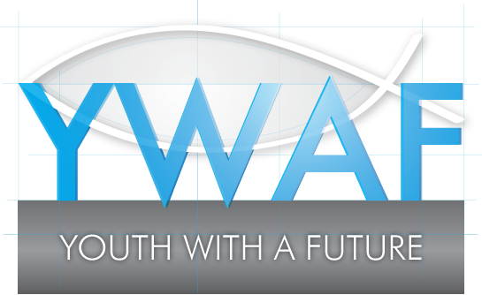 **GRANTS FOR COMMUNITY GROUPS – FEEDBACK FORM**

|  |
| --- |
| Name of Community Group:  Charity number (if registered charity): |

|  |  |  |
| --- | --- | --- |
| Your name and position: | Email: | Tel no: |

|  |  |
| --- | --- |
| Project:  Started:  Completed: | YWAF grant received: £  Total actual project expenditure: £ |

|  |
| --- |
| How was the YWAF grant spent?  Were any changes made to the original project plan described in your application?  How many young people were directly supported by this project?  What beneficial impact will this project have going forward? |

|  |
| --- |
| On a separate accompanying page, if possible, we would be delighted to receive a story about a specific group or individual benefiting from this project, including any supporting photos (having obtained the appropriate consents from any persons featured). |
| I confirm that I am authorised to submit this feedback form for and on behalf of our named community group, a true record of this YWAF grant funded project. |

Signed........................................................................................... Date ……………………………….

**Grant Feedback Form**

Community Groups are encouraged to complete a feedback form 12 months after receiving grant funding from YWAF.

**Why do we request grant feedback?**

We consider grant applications carefully, so that we can make the right funding decisions in line with our charitable objects.

Having made a grant, the feedback form lets us know that projects or activities are meeting the identified need and that funds are being used effectively.

**How do you complete a grant feedback form?**

Please download the form (a word document) from our website ([www.ywaf.org.uk](http://www.ywaf.org.uk)), complete, and then email or post back to us.

**What happens if our community group does not provide feedback?**

Providing feedback is part of the terms we ask you to agree to when applying for a YWAF grant.

We’ll contact you if the feedback form is not received. If you still choose not to supply, then it is most unlikely that YWAF will provide your community group with any further grants.